Experiment-2

Verification of the Overfitting Issue Using a Numerical Dataset in Python

⬛ AIM
To verify the occurrence of overfitting by training a simple model and a high-complexity model on a numerical dataset and comparing their training and testing errors using Python.

⬛ ALGORITHM

Algorithm to Verify Overfitting
- Start
- Generate or load a numerical dataset.
- Split the dataset into training and testing sets.
- Fit a simple model (Linear Regression).
- Predict values for both training and testing sets.
- Compute training error and testing error using Mean Squared Error (MSE).
- Fit a high-complexity model (10-degree Polynomial Regression).
- Predict values for both training and testing sets.
- Compute training error and testing error for this model.
- Compare errors:
  - If training error << testing error, overfitting is occurring.
- Display the errors and conclude.

Stop

⬛ INPUT & OUTPUT

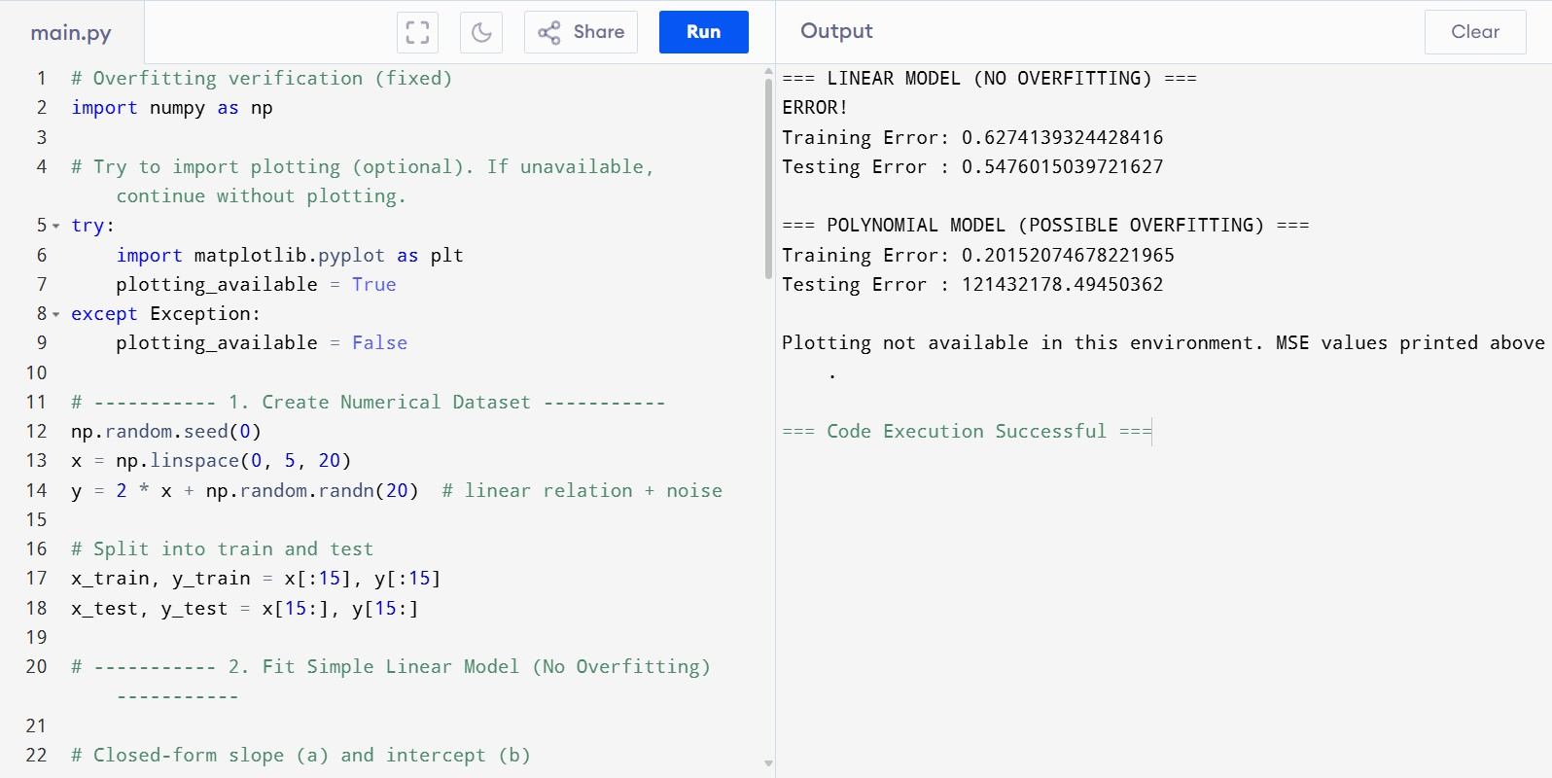

⬛ RESULT
The experiment successfully demonstrated the overfitting issue.
The polynomial (high-degree) model achieved a very low training error but a very high testing error, proving overfitting.

Linear Model:
  - Training Error ≈ Testing Error → No Overfitting

Polynomial Model:
  - Training Error very low
  - Testing Error very high → Overfitted model
Thus, the performance difference clearly verifies overfitting in the high-complexity model.

